Here are the requirements that we have for the new POS. All these factors are important to us and have been collected after years of being in the business.
- 1.- POS for small and large retail stores, small and large corporate restaurants, bars, pizza, and all involved.
- 2.- Automatically integrate with UBER EATS and DOOR DASH, GRUB HUG, and find a way for these companies to pay us for giving them access.
- 3.- When an ISO wants to integrate, find a way for them to leave us some residual profit.
- 4.- Have the option of reservation and accept payments to cover a debt (Layaways)
- 5.- Create a customizable map of tables based on preferences and needs.
- 6.- Label the tables and chairs with letters from A to Z, starting from the left.
- 7.- Display the name of the waiter on the ticket at the table.
- 8.- Include item types in the menu for accounting control.
- 9.- Explore options for customers to order from their table and consider adding cost-based games to benefit from it. Table Ordering Tablet like (Ziosk). But the most important part is let the kids play with a charge $$. https://en.wikipedia.org/wiki/Ziosk
- 10.- Completely D….. tickets after viewing them, like ALDELO.
- 11.- Ensure PCI compliance.
- 12.- Open bar tabs and easily find them using the name or card.
- 13. Include the option to display the time when the order was sent on the ticket, and the manager can see it on their phone or tablets.
- 14.- Display the suggested tip percentage and total $ amount on the receipt for customer convenience.
- 15.- Designate a specific station as the cash register for cash payments.
- 16.- Keep the cashier within the system and menu to save steps.
- 17.- Add a button to order items not found in the menu, categorized by department (Miscellaneous, Bar Miscellaneous, Party Pack, Gift Card, etc.,
- 18.- Implement a cash discount option, controlled, and authorized by us only. Customers who decline the cash discount should not have the option to enable it.
- 19.- Allow transferring of tickets to other waiters with and/or without manager authorization.
- 20.- Change table locations with or without manager authorization.
- 21.- Option for waiters to not be able to clock out until they have closed all their tables.
- 22.- Each waiter can act as their own bank, and the report shows how much cash they have on hand. If they have received tips, it should be deducted from that amount. They should also be able to cash out the money they have collected to pay their tips.
- 23.- When waiters finish their shift, they have the option to report their tips. The manager can set a minimum tip requirement (e.g., 15%) or prevent them from leaving.
- 24.- When reporting tips, waiters can allocate a certain percentage to assistants, bartenders, etc., and the system will apply that percentage to distribute the money, accordingly, notifying the recipients where the money comes from. These tips should be automatically reported on the paycheck.
- 25.- Is it possible to edit the batch and settlement of card transactions after they have been sent to the bank? Can there be a grace period in the system to pause the sending of settlements to the bank for a certain time (e.g., 1 hours) to allow for tip editing?
- 26.- Waiters should have access to view their sales and tips with the appropriate permissions.
- 27.- Practice mode should be available for training purposes, but the results should not be reported as actual sales. Managers should be able to review the practice sessions.
- 28.- The POS system should nidificate and print the ticket when the kitchen or bar printer is not functioning.
- 29.- When the keyboard opens, the keys should be large and easy to press.
- 30.- Ticket Notes should be included on the bottom of the ticket for the cook to see it.
- 31.- The option to have sequential or random ticket numbers.
- 32.- Employee codes should be hidden in the employees file, and if lost, they can be recovered with manager approval.
- 33.- When adding a new employee, all necessary folders should be created, including the Liquor License Certificate.
- 34.- Employees can log in using fingerprint, code, cards, or other methods.
- 35.- Waiters should only be able to access the system after clocking in, Optional.
- 36.- Easy copy and paste menus from other POS to our POS,
- 37.- Integrated QR code generator.
- 38.- Table-specific QR codes to see the menu and ordering.
- 39.- Ability to resend items to the kitchen and bar.
- 40.- Ability to reorder a round or anything previous order by just clicking the item in the ticket.
- 41.- When it comes time to pay, multiple payment methods should be accepted, including multiple cards for a single ticket (Credit Cards, Gift cards, Cash, Crypto, or any other).
- 42.- Any changes made to the menu should automatically update across all businesses within the corporation (When they have multiple locations).
- 43.- Create an app with all the necessary reports and tools for the owner to manage from their phone or tablet.
- 44.-Develop a guest app that displays order history and enables customers to pay by scanning the ticket without handing their card to the server (like Heartland POS). https://youtu.be/LeVVXV5--Z0?si=jLaajOtqwrGlvunI
- 45.- Be able to see all the used tables and when every single order is placed live.
- 46.- Look for the way to load the tips onto prepaid cards for employees.
- 47.- Integration with QuickBooks

Inventory
- .- Full control of Inventory.
- https://youtu.be/2KMH1uMXPjc?si=McKe5603p09ochJC
- https://youtu.be/iVOYex9NWDo?si=X1UO8I8SkjWeqEGm

Reports
- 48.- Employee payments are biweekly (26 weeks), but some companies want to pay weekly (52 weeks).
- 49.- Automatically deduct the cash when tips are paid (Like Aloha).
- 50.- Schedule where employees can choose and exchange their shifts with others, with managers approved or manager knowledge.
- 51.- Price change reports.
- 52.- Keep a history Log and who did it: when someone do a Void, Discount, Price Change, or any other important thing that the owner would like to know.
- 53.- Display sales reports in the form of graphs for viewing on mobile devices or the web (SpotON). They have 77 available report options. I LIKE THESE REPORTS

Notifications:
- 54.- Send the corresponding notifications to the owner or manager: Voids, Comps, Discounts, Cancellations, etc. by Email, Pdf, text, Excel, etc.
- 55.- Ability to send messages within the group, either individually or all entire group.

To-Go Orders/Pizzas
- 56.- Have the option to input customer information to save their data and be able to access their order history.
- 57.- Know what the customer has ordered or determine what type of customer they are.
- 58.- If we offer delivery, be able to view the map and track the driver's location.
- 59.- Have a field to enter the driver's license for the driver.
- 60.- Calculate the distance in miles to be able to charge per mile driven.
- 61.- For online orders, automatically update the prices from the local menu, and when orders are placed, print a notification at the cash register and direct to the kitchen.
Waiter sending orders
62.- Keep the main page as clean as possible, activating only the necessary elements when buttons are pressed.
63.- Have the option to Send and Stay to continuing with the order. For example, if the customer wants appetizers quickly, they can send those items immediately while continuing to add to the order.
64.- Make the ordering process for servers as simple as possible, minimizing the need for them to leave and re-enter the order.
65.- Allow customization of quantities for specific items when ordering. For example, if someone orders tacos, they can specify the quantity of beef, chicken, pork, etc. they want.
66.- Enable unlimited splitting of the ticket.
67.- When splitting the ticket, keep all the tickets on the same screen and make them available for adding or removing items.
68.- Provide the option to split the bill within the same ticket, and if desired, view the split amounts in separate tickets without leaving the screen (like "Manage Table" feature in SpotON).
69.- Allow splitting of a single item and assigning it to multiple individuals.
70.- Repeat an entire round of orders with a single button press.
71.- Include a search button on the menu interface for faster product lookup if the user is unsure of its location (this will display multiple options with prices and locations and can be selected from there).
72.- Use a "MOD" button with options such as "NO," "LIGHT," "ADD," "EXTRA," "INSIDE," and "ADD Mode" for modifications. For example, if the menu item is "Chicken," pressing "NO" will display "NO Chicken" Add or Extra may need to be with extra charge.
73.- Offer multi-column modifiers, where all modification options are listed in separate columns for easier selection (similar to Future POS). https://youtu.be/vSqT22b19Dk?si=Awy26zC1scBQG-0C
74.- Provide a notes section for the kitchen to include specific instructions for an order.
75.- When ordering a product with modifications or additions that incur additional charges, have the option to calculate and display the total cost of the main product. For example, 1 Margarita for $10 with Patrón for $5 (in small font and/or possibly removing this price) Total show as Margarita $15.
76.- Allow each server to have their own cash bank, generate reports, and reconcile their cash at the end of their shift.
77.- Support dual pricing, like the HotSauce system.
78.- Integrate Caller ID for takeout orders this way you know the customer’s name.
79.- Handle cases where a customer may have multiple phone numbers or a single phone number is used by multiple customers, ensuring the system can associate the correct data with the corresponding customer (e.g., schools with shared phone numbers).

Cashier
- 80.- Place a button upfront for applying discounts, and within that button, include options such as Tax Exempt (with the ability to enter the Tax-Exempt number), Employee discounts, Police discounts, Coupons, etc. The discount amount should be visible before applying it to the ticket and there should also be an option to remove the discount.
- 81.- When customers want to pay using multiple payment options (Cash, Credit Card, Gift Card, etc.), ensure a seamless process that allows them to split the payment as desired, while keeping the ticket open without any issues.
- 82.- Enable cash register opening without requiring a sale.
- 83.- Offer the ability to send receipts to customers via email, text, etc.
- 84.- Provide the capability to give credit to a customer, whether it's through a Credit Card, Cash, or Gift Card.
- 85.- Allow voiding of credit card payments but keep track of who did it.
- 86.- Enable partial credit to be applied to a credit card account that has already been paid.
- 87.- Is it possible to integrate a camera that can instantly communicate with the POS system?
- 88.- Can cryptocurrency integration be implemented?
- 89.- Support both physical and electronic gift cards, allowing for immediate or birthday-specific delivery.
- 90.- Set a maximum discount limit based on the employee's level within the system.
- 91.- Ensure that the Cash Discount ticket, when printed from the Credit Card Machine, clearly indicates the amount paid by the customer.

Making the menu
92.- Allow copying or cloning of items, modifiers, or force modifiers, and then rename the new product as desired.
93.- When the price of a modifier is changed, automatically update the price of the corresponding force modifier.
94.- Provide the option to add photos of dishes or drinks. (Create a folder and make it accessible for basic items: beer caps, sodas, juices, vegetables, fruits, etc.)
95.- Schedule events: Enable the creation of events throughout the year and make it easy to set the date and time for special events, holidays, and control labor cost (as seen in SpotON). https://youtu.be/j0PRhhxp558?si=nY7cHDAugM_vaCC9

Setting up the system:
96.- Set up printers from the server without having to configure them on each POS individually.
97.- Have the "?" or Help button prominently displayed or easily accessible, allowing users to check for internet connectivity and providing quick access for customers to provide tools for tech support.
98.- Pre-install the drivers for the printers that will be used.
99.- Pre-install the POS software to our hardware.
100.- Pre-install TeamViewer and AnyDesk or other remote access software to our hardware.
101.- Make the printer installation process user-friendly and easy.
102.- Make the integration of PAX or any other devices straightforward.
103.- Set up PAX or any other devices with First Data and/or Tsys.
104.- Restrict actions and changes without approval from the designated authority.
105.- Perform updates periodically and assess the impact on clients' current settings before deciding to proceed, ensuring that the updates do not disrupt their existing configurations.

Hardware:
Looking to use like Toast POS. https://central.toasttab.com/s/article/What-Kind-of-Hardware-Do-I-Have
Looking to have Elo POS System https://www.elotouch.com
Looking to have Ubiquity to avoid Internet Downtime, and I am open for your suggestions

106.- Meraki Backup Router
107.- I have experienced many POS systems freezing, so please let's avoid this situation.
108.- Ensure that the system never slows down due to internet issues or excessive data accumulation. "We cannot afford this issue, as it is common with many POS systems."
109.- Have the option to periodically compact the data.
110.- Provide the option to back up customer data to our server to prevent any crashes and facilitate reinstallation of the client's server. Also, allow clients to easily perform their own backups. However, 111.- Ensure that our POS system's internal structure remains hidden, as opposed to BLogic, where the entire framework can be seen.
112.- Activate or Deactivate the hardware exclusively with special codes from our POS system.
113.- Utilize kitchen monitors (Android) and paper printers.
114.- Incorporate customer display monitors.
115.- Set up servers.
116.- Deploy POS terminals.
117.- Use tablets.
118.- Implement handheld devices.
119.- Integrate barcode scanners.
120.- Include card readers.
121.- Utilize all-in-one computers for deposits.
122.- Use printers specially designed for our POS system with labeled and color-coded connectors (Code Coded).
123.- Utilize Cisco routers.
124.- Purchase hardware with an aesthetically pleasing design that conceals cables.
125.- Ensure that the logo is imprinted within the hardware and not simply added as a sticker.

Mobile App:
126.- Develop an app to promote our company's POS system.
127.- Allow users to view the staff members currently working and track labor expenses versus sales through the app.
128.- Enable simultaneous monitoring of multiple locations for business owners with more than one establishment.
129.- Provide live views of tables, allowing owners to see on the app if a beer was served when they review the camera footage.
130.- Display common reports, including:
131.- Labor reports to track hours worked.
132.- Daily sales reports and customizable time period reports.
133.- Deposits from card transactions.
134.- Detailed transaction history for each card.
135.- Chargeback records.
136.- Sales reports for each server.

Website & Optimization:
137.- Implement search engine optimization (SEO) strategies during the development of the POS system to enhance its visibility on Google and improve its ranking on search engine result pages.
138.- Design the POS system to cater to small companies and large Corporations.
139.- Install a tablet at the cashier station where customers can enter their information, which will automatically integrate with the POS system for reward points.
140.- Develop a guest app that displays order history and enables customers to pay by scanning the ticket without handing their card to the server and clear at the pos system (like Heartland POS). https://youtu.be/LeVVXV5--Z0?si=jLaajOtqwrGlvunI
141.- Provide live chat support on the website, connecting users with sales representatives who will earn commissions for sales made through these chats and maintain records of the interactions.

SPECIAL IMPORTANT FEATURES:
142.- Integration with management companies.
143.- Full integration with major back-store recording systems.
144.- Consolidated all deposit (Settlements) for all POS units from the Cashier Station..
145.- Separate weekend deposits for individual days.

CONTROL AND NOTIFICATIONS:
146.- Control and monitoring of all licenses, with notifications sent if someone attempts to use a license that is already in use on another device, to prevent hacking attempts.

TRAINING VIDEOS AND TOOLS:
147.- Create tutorials in English and Spanish, featuring Angel and Cynthia.
148.- Develop a robust website.
149.- Provide 24/7 customer support with a commitment to answering calls within 1 minute.
150.- Implement a classroom training system.
151.- POS tutors for personalized training.
152.- Access to the Main Source Code.
153.- User manual.
154.- Architectural diagram.
155.- Implement high availability or disaster recovery servers in multiple locations worldwide, with a load balancer for synchronization in case of failure.
156.- Dedicated server for software hosting.
157.- Dedicated server for cloud hosting.
158.- CI/CD DevOps system for automated upgrades across multiple machines.

⁃ Toast can send Text Notifications when food is ready on the To-Go or Food Truck
159.- Let the Credit Card file see all the Pax Connected and see and find the IP automatically
160.- On the employee reports must have the option to see all thickets sold with the number, amounts and other basic info needed by this employee.
161.-
162.- In the TO-GO Orders only. Let the cashier or server print the ticket with all modifiers as the kitchen, this way the cashier knows what to pick up.
163.- Don’t let the server use the system unless they are clocked in, but this must be in the Employees Authorization list, this way if the owner can let some employees or manager use it without clock in.
164.- All feature for the Retail Store (Super Market) Scales, Inventory, Bar Codes, etc.
165.- POS should have a built-in camera to SCAN the tickets and hope we can do Face Recognition.
165.- All deposit (Settlement) must be done in the Cashier.
166.- Make the Kitchen and Customers ticket to be customize as small as the merchants wants it, this way they save paper.
167.- Can we lock it to use exact he hardware we need to be?
168.- When they do split and one of the customers pay their part, some POS don’t let the server continue doing splits or add more foods, please make it available.
169.- On the TO-GO make the option to ask for the name or the phone number as optional and all the others to create the profile
170.- Menu Link inventories
171.- Bar Keep inventories
172.- Yogurt Store (they use scales)
173.- Donations button without any charge $$$
174.- Payment Facilitator
175.- Can we implement the option to accept Bitcoin as Payment Method??????
176.- Set up thy system to automatically create our password for the TeamViewer and AnyDesk
177.- Pre-Authorization TOKEN for Open Tabs at the bar.
178.- When offline, make sure the POS recognizes it quickly and goes into offline mode soon after. Avoid long wait times for transactions due to POS looking for internet making sure they can input the tips.
179.- El TeamViewer and AnyDesk must be integrated into the motherboard. Is it possible?
180.- Organize the Menu Modifiers as the customer choose, Alphabetic or the way they input it,
181.-
182.- make sure to use the best tools available to make this pos fast, can’t afford to have failures.
183.- HungerRush.com shows the delivery map and options to manage the driver route. https://insights.hungerrush.com/videos/hungerrush-dispatch-feature-demo
Customer Data with details https://insights.hungerrush.com/videos/easily-access-customer-data-and-delivery-preferences-in-one-click
Order Automatically over the phone with a robot https://insights.hungerrush.com/videos/orderai-talk-ordering-demo
Can we make the Front menu to be use by a Left Hander person by just clicking a button? https://insights.hungerrush.com/videos/hungerrush-ease-of-use-feature-demo
184.- It looks east to place the orders
185.- Emails Services
186.- Text Services
187.- Make all batches (Deposits) from the Cashier Station
188.- DK (Kiosk Display)

Points sent by mail:-

189.- When counting the money give them the opportunity to count bills, coins etc.
190.- Before they do the End the Shift give them the opportunity to check the report before finishing it. (Optional with Manager permission in settings)
191.- Inventories like Crunchtime
192.- The Sales Report must show the Merchant fee and all.
193.- On the Batch History, add a line on the bottom of each day with the total of Sales, Deposits, Tips, etc.
194.- Knowledgebase and Q&A (User Manual)
195.- Quick book Integration
196.- Taxes to be reported to pay to the IRS automatically in a weekly, monthly, Quarterly, or customize
197.- Corporations wants to withdraw their fee from the Franchisee daily direct from the POS in conjunction with the ISO. Make it available.
198.- Discounts and Promotions, (When a promotion like Buy 1 Adult and Kids eat FREE, Discount in %, or Discount in $, with the date and time to schedule) (When and Item needs to be in Special, have the option to discount it)
199.- Happy Hour: Make simple to set the time. If the happy hour is set to be Mon-Fri from 11am to 4pm. (Make it for us to mark those days and that time and that’s it), Nothing else.

200.- When the system goes Offline make sure not to charge double to the customer pretending that the first transaction didn’t go true.
201.- The tablet screen view must look identical to the POS, but smaller size of course.
202.- Be able to pair the paxes IP addresses automatically just by pairing the units.
203.- Send and Stay Button to continuing placing the order.
204.- Have a Button to discount (Change Price) to an item when the ticket is created (with Managers approval) Aldelo Has it
205.- When you are sending a ticket with various items to various kitchen printers, have the option to print on the Bottom of the ticket (This item goes with xxxx items in the same ticket) this way the cooks talk each other to see how quick he will have the other item ready this way all the food come out at the same time, (Aldelo Has it)
206.- **** Also, and so IMPORTANT. At the same time the developers are building the POS, I want them to be adding content of WHAT they do, and HOW they do it, into my OWNERS MANUAL, this way whoever is doing Tech Support will have the Access to learn and know how to offer Customer Service and or Trouble Shoring. *****

- 207.- Assign tables to employees (Table create a special design to match the server design as well. TOAST https://central.toasttab.com/s/toast-classroom
- 208.- For Open Items, must open a window where it is going: Open Food, Open Liquor, or Open Beer, this is to categorize and to send it to the appropriate printer.
- 209.- Set a Tab Name option in each ticket
- 210.- All Checks, this is for the Server to see all his checks.
- 211.- Be able to create and send Catering Invoices from the POS.
- 212.- Clock OUT Time: Show their Open Tables, ask if they already did all their Side work with a list of duties, Cash TIPS Report Reporting the TIPS for all the Employees you share the tips with. (This will be for Server and Bartenders ONLY)
- 213.- In PAID Checks be able to cancel the payment, Issue the Cancelation in that minute without going to the bank and wait days for it.
- 214.- Make a DISCOUNT Button in the front of the check and also make an option available to click in the item a discount per item too.
- 215.- QUICK EDIT MODE: Click on the ITEM and Manager can Edit the price, Item, Out of Stock, and more. This will also help the Inventory.
- 216.- Corkage Charge, Service Charge. And Who will get this Money: Owner or Employee?
- 217.- After the Check is Paid: be able to see all the checks and do some changes on 3 buttons like: REPRINT, VOID, and ADJUST: Adjust Tips, Move Payment to a different check.
- 218.- ON Toast: when the system goes Offline: here is what they can continue doing up to when the Internet comeback. See Picture bellow.
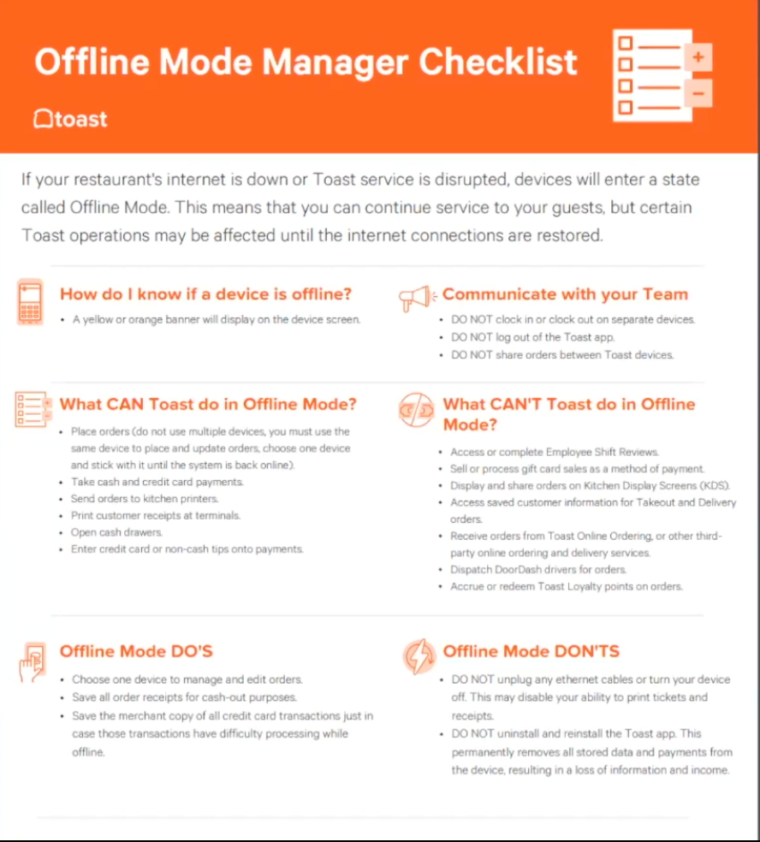

- 219. Be able to pull reports by custom hour ( They want to know how much they sold in Breakfast Only, o Lunch Only, or Dinner Only in a month or a year )
- 220. Module wise access to customers controlled by TequilasPOS (Superadmin)
- 221- Where there are multiple Credits Card Machines to batch out, make sure to control all of them with the Cashier. So when the cashier is ready to settle the system must tell all other POS to settle automatically. This way the cashier don’t need to go to every one to settle and all of them settle at the same time.
- 222- When multiple locations business sale a Gift cards, it can be use to any of their locations.
- 223 - Please make sure we develop an app to use a handheld like Pax920 to be use with the Cash Discount with out using the Tequila POS, as a reference you can take a look at Blogic POS Express. This can be use when the POS is not working, we can use this as a back up Stan alone machine

